# C2- S4 – PRACTICE- **BUS TRIP**



We want to manage BUS trips, and customers going to each trips

* A Trip
  + Has a list of customers,
  + The bus is going from a departure address to an arrival address
* A customer
  + Has a first/last name
  + Can have an address , but he/she does need to mention it
* Address must be defined using class , as it contains many information

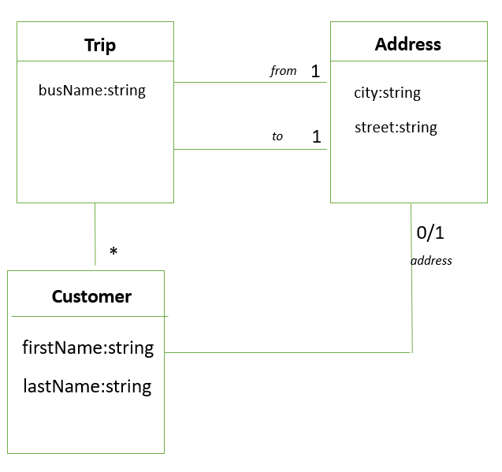

**Q1** Create the **OOP model** (classes / attributes/ constructors / setters) needed to match with this problem

**Q2** Create the following **instance** of this OOP model:

**CUSTOMERS**

| **First name** | **Last Name** | **Address** |
| --- | --- | --- |
| Ronan | Ogor | Paris, France |
| Him | Hey | *No address* |
| Sovanda | Chib | Phnom Penh, Cambodia |

**TRIPS**

| **Bus name** | KAKA Bus |
| --- | --- |
| **Departure place** | Phnom Penh, Cambodia |
| **Arrival place** | Kampot, Cambodia |
| **Customers** | Him, Sovanda |

| **Bus name** | LYHOR Express |
| --- | --- |
| **Departure place** | Phnom Penh, Cambodia |
| **Arrival place** | Sieam Reap, Cambodia |
| **Customers** | Him, Sovanda, Ronan |

BONUS

*(This part is optional: it will give you more points, but ONLY if the first part is correct!!!)*

We want now to manage when the bus is leaving and arriving at tis destination:

* The bus is leaving at a specific date/time and arriving at a specific date/time
* We create a class DateTime to manage both date and time together

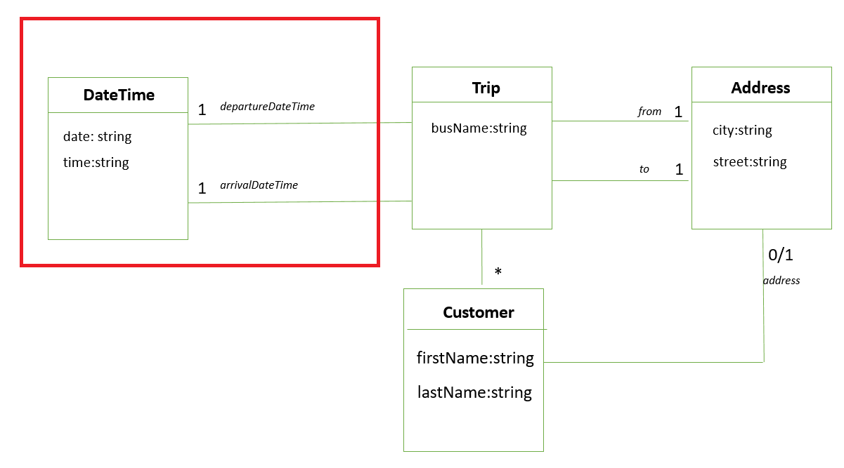

**Q1** Update the **OOP model** (classes / attributes/ constructors / setters) needed to match with this new problem

**Q2** Update your bus instances to add their start and end date and time

* + - *Any data / time you want*